AI duPont Middle School: After School Tutoring/Homework Help

Permission Slip



Every Tuesday & Wednesday

3:00 PM - 4:45 PM

Cafeteria

Students must sign-up using the **Google Form** no later than the **Friday** before the following Tuesday/Wednesday.

Students must have a signed permission slip on file to stay for after school tutoring.

Student can take Activity Bus home. Bus will use Activity Stops. (See Back)

Food will be provided.

Google Form Link: <https://docs.google.com/forms/d/e/1FAIpQLScbzg_lmogMr6dkG-G8R954MHkliFD1ocJtYlf9WyB4WAGIiQ/viewform>

Student’s Name: ______________________________________

Parent’s Name: ______________________________________

I give permission for my child to stay after school for tutoring on day(s) checked below. I understand that transportation will be provided if I am unable to pick him/her up.

Parent Signature ______________________________________________________________________________

Phone Number _____________________________ Emergency Number_________________________________

*After School Tutoring permission slips must be on file. If permission slips are not on file, students are not permitted to stay after school.*

**Please Check all appropriate boxes below:**

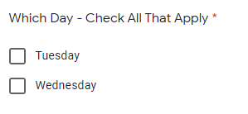 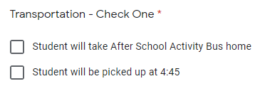

(Activity Bus Stops Listed On Back)